Solent University

Faculty of Business, Law and Digital Technologies

**The Software Project**

**Selecting a mobile device**

**based on PhoneDB data**

Author : **Ivan Rubinov, Q102110038 student code**

Course Title : **Programming for Problem Solving, COM728**

Module Leader : **Jarutas Andritsch**

Date **: 01.01.2024**

Table of Contents

1. Overview 4

2. Project Implementation 5

2.1 Project structure 5

2.2 Modules/ Functions 7

2.2.1 Main module, an entry point (main_file.ipynb) 7

2.2.1.1 The prompting a file name. 7

2.2.1.2 The executing Interface menu 7

2.2.1.3 Constant with all possible Interface menu options 8

2.2.1.4 Constant with all possible retrieval conditions 9

2.2.2 Menu_module 10

2.2.2.1 Function input_file_path() 10

2.2.2.2 Function input_choice() 11

2.2.2.3 Functions input_value() and input_value_range() 12

2.2.2.4 Functions input_feature() 12

2.2.3 Retrieve_module / function retrieve() 13

2.2.3.1 Reasons for build retrieval conditions 13

2.2.4 Key_match_module / function find_by_key() and find_by_key_range() 14

2.2.5 Analytics_module / function analytics_visualize() 15

2.2.5.1 Function avg_group_filter() 15

2.2.5.2 Function avg_group() 16

2.2.5.3 Function count_group_two(). Reasons to build it 17

2.2.5.4 Function top_features() 18

2.2.5.5 Function pie_chart_filtered() 19

2.2.5.6 Function chart_counted() 20

2.2.5.7 Function chart_monthly_price() 21

2.2.5.8 Function chart_metrics_three(). Reasons to build it 22

3. GitHub Repository Evidence 24

Table of Figures

Figure 1 Software Project. Modules structure (adapted from Andritsch, J., 2022) 5

Figure 2 Software Project continued. Analytics module structure (adapted from Andritsch, J., 2022) 6

Figure 3 Code to call the function requesting the file name. 7

Figure 4 Example of requesting the file name 7

Figure 5 Code to select for a menu option and run the corresponding module 8

Figure 6 Code of possible menu options, const ‘choice_list’ 8

Figure 7 Example of executing Interface menu 9

Figure 8 Code of possible filter conditions, const ‘retrieve_condition’ 10

Figure 9 Code of function asking a filename, input_file_path() 11

Figure 10 Code of function visualising menu interface, input_choice() 12

Figure 11 Code of functions input_value() and input_value_range() 12

Figure 12 Code of function asking a feature name, input_feature() 13

Figure 13 Beginning code of function retrieve() 13

Figure 14 Example of retrieving devices 14

Figure 15 Code of functions to search by key, find_by_key() and find_by_key_range() 15

Figure 16 Beginning code of function analytics_visualize() 15

Figure 17 Code of averaging function avg_group_filter() 16

Figure 18 Example of analyse of the average price of device 16

Figure 19 Code of averaging function avg_group() 17

Figure 20 Example of averaging weight for each manufacture 17

Figure 21 Code of counting function, count_group_two() 17

Figure 22 Example of counting device grouped by brand and released year. 18

Figure 23 Code of counting function, top_features() 19

Figure 24 Example of top regions for Apple brand 19

Figure 25 Code of visualising function pie_chart_filtered() 20

Figure 26 Example of proportion of RAM types 20

Figure 27 Code of visualising function, chart_counted() 21

Figure 28 Example of number of devices for each USB connector Type 21

Figure 29 Code of visualising function, chart_metrics_three 22

Figure 30 Example of monthly average price chart 22

Figure 31 Code of visualising function, chart_metrics_three 23

Figure 32 Example of comparing between brands 23

Figure 33 Github commits 24

Figure 34 Commit history in GitHub 25

Index of Tables

Table 1: Requirement Completion 4

Table 2: List of all functions in alphabetical order 6

# 1. Overview

The project’s aim is a help with selecting the most suitable mobile device. Users can find and analyse device features extracted from the PhoneDB website in the form of a CSV file.

This file provides technical data for smartphones, tablets, PDAs, and other mobile devices. There are technical specifications such as weight, display and dimensions, as well as marketing data such as selling prices and regions where device is distributed.

The file contains 48 columns separated by commas. Each row represents one device released in 2020-2023 years. Possible column datatypes are text, numbers or datetime.

The project delivers a proper value to users saving their time and money. Users can make the better decisions, reveal existing trends and patterns through data analysis and visualization.

Below is a table with requirements achieved.

Table 1: Requirement Completion

|  |  |  |
| --- | --- | --- |
| **#** | **Requirement** | **Status** |
| a | Load the data from a CSV file specified by the user using the CSV reader function. | Completed |
| a1 | Retrieve the model name, manufacturer, weight, price, and price currency based on the oem_id. | Completed |
| a2 | Retrieve the brand, model name, RAM capacity, market regions, and the date based on code name. | Completed |
| a3 | Retrieve the oem_id, release date, announcement date, dimensions, and device category based on RAM capacity. | Completed |
| a4 | Custom retrieval. Information from three columns (‘hardware_designer', 'display_diagonal', 'sim_card_slot') and apply a specific condition (‘weight’) | Completed |
| b | Load data from a CSV file using the pandas module. | Completed |
| b1 | Identify the top 5 regions where a brand was sold. | Completed |
| b2 | Analyse the average price a brand, all in the same currency. | Completed |
| b3 | Analyse the average mass for each manufacturer. | Completed |
| b4 | Analyse the data to derive meaningful insights based on unique selection, distinct from the previous requirements (custom). | Completed |
| c | Load data from a CSV file into memory. | Completed |
| c1 | Create a chart to represent the proportion of RAM types. | Completed |
| c2 | Create a chart with the number of devices for USB connector types. | Completed |
| c3 | Create charts illustrating the monthly average price trends (in GBP) for devices released in each year from 2020 to 2023. | Completed |
| c4 | Custom visualisation. Charts comparing two brands by three metrics: median memory capacity, median weight and max selling price in USD | Completed |

**Status options:** Completed/ Partially Completed/ Not Attempted

# 2. Project Implementation

An initial dataset is loaded in memory by using CSV reader module (*‘retrieve_module.py’*) or pandas module (*‘analytics_module.py’*). The path of the dataset is provided by the user. CSV reader module is used for retrieving device columns, while pandas module is used for analytics such as finding of top regions or average prices. Matplotlib module is used to visualize the data and reveal trends and patterns.

#### 2.1 Project structure

The diagram below illustrates the project structure. There are five modules (files):

* Main module to run the program, an entry point
* Menu module to interact with a user and prompt input values.
* Retrieve module to find/filter devices by features
* Module to work with keys and dictionaries
* Analytics module to aggregated and visualise data



Figure 1 Software Project. Modules structure (adapted from Andritsch, J., 2022)



Figure 2 Software Project continued. Analytics module structure (adapted from Andritsch, J., 2022)

Table 2: List of all functions in alphabetical order

|  |  |  |  |
| --- | --- | --- | --- |
| **Function name** | **Module where it is defined** | **Module where it is used (called)** | **# specific task** |
| analytics_visualize() | analytics_module | Entry point(main module) | c |
| avg_group() | analytics_module | analytics_module | b3 |
| avg_group_filter() | analytics_module | analytics_module | b2 |
| chart_counted() | analytics_module | analytics_module | c2 |
| chart_metrics_three() | analytics_module | analytics_module | c4 |
| chart_monthly_price() | analytics_module | analytics_module | c3 |
| count_group_two() | analytics_module | analytics_module | b4 |
| find_by_key() | key_match_module | retrieve_module |  |
| find_by_key_range() | key_match_module | retrieve_module |  |
| input_choice() | menu_module | Entry point(main module) |  |
| input_feature() | menu_module | analytics_module |  |
| input_file_path() | menu_module | Entry point(main module) |  |
| input_value() | menu_module | menu_module, retrieve_module |  |
| input_value_range() | menu_module | retrieve_module |  |
| pie_chart_filtered() | analytics_module | analytics_module | c1 |
| retrieve() | retrieve_module | Entry point(main module) | a, a1, a2, a3, a4 |
| top_features() | analytics_module | analytics_module | b1 |

#### 2.2 Modules/ Functions

##### 2.2.1 Main module, an entry point (main_file.ipynb)

This module is an entry point to run the program and call other modules.

Modules consists of two parts.

###### 2.2.1.1 The prompting a file name.

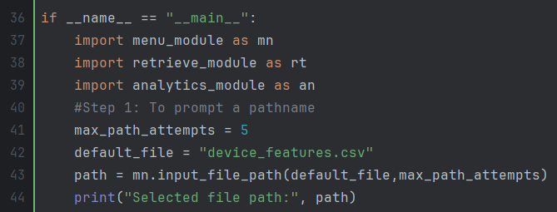

Figure 3 Code to call the function requesting the file name.

Constants

* *‘max_path_attempts’* – the max number of attempts to request a file name
* *‘default_file’* – the file name by default.

Figure 4 Example of requesting the file name

###### 2.2.1.2 The executing Interface menu

Figure 5 Code to select for a menu option and run the corresponding module

Variables (‘*min_retrieve’, ‘max_retrieve’, ‘min_analytics’, ‘max_analytics’*) are lower/upper boundaries to determine which module to execute: retrieve or analyse.

###### 2.2.1.3 Constant with all possible Interface menu options

The value of boundaries is corresponded to index values of constant ‘*choice_list’.* Having all the menu options in the one list makes easy adding new options.

Figure 6 Code of possible menu options, const ‘choice_list’

Figure 7 Example of executing Interface menu

###### 2.2.1.4 Constant with all possible retrieval conditions

The similar solution where all data is kept within one dictionary was applied to call the retrieval module.

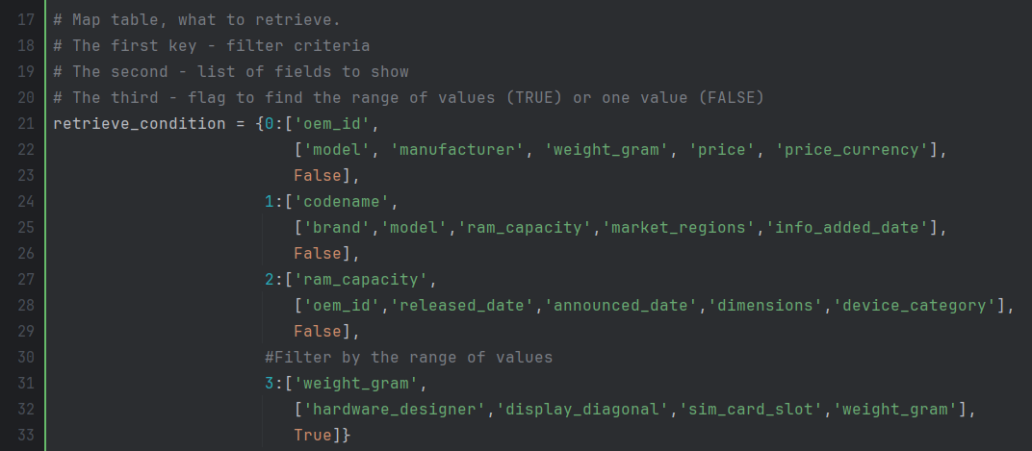

Figure 8 Code of possible filter conditions, const ‘retrieve_condition’

In the code above there are four conditions with numbers from 0 to 3. Each condition has the list with three keys.

First two keys are name(s) of the device features:

* filter the dataset (like *‘oem_id’*)
* display the results after the filtering (like *‘model’, ‘manufacturer’*)

The third key is a special flag responsible for

* searching by one value
* searching by value range.

The initial project requirements do not have such a flag, but it was helpful for finding devices by a price range in my custom search.

##### 2.2.2 Menu_module

###### 2.2.2.1 Function input_file_path()

Takes two parameters:

* default path (returns it if user leaves the prompt blank)
* max number of tries to request the file name.

Returns:

* the path

Figure 9 Code of function asking a filename, input_file_path()

The example of usage can be found in Figure 4

###### 2.2.2.2 Function input_choice()

Takes one parameter:

* all the possible menu options as a list

and visualises them in the menu loop.

Returns:

* the index number of the selected menu option.

Figure 10 Code of function visualising menu interface, input_choice()

The example of usage can be found in Figure 7.

###### 2.2.2.3 Functions input_value() and input_value_range()

Both functions take one parameter:

* Name of key

Then prompt and return:

* A value (or a value range)

Figure 11 Code of functions input_value() and input_value_range()

###### 2.2.2.4 Functions input_feature()

Takes two parameters:

* the dataset to filter
* the feature name to be filtered

Then prints all possible values and asks the user to enter the right one.

Returns:

* a value selected by user

Figure 12 Code of function asking a feature name, input_feature()

##### 2.2.3 Retrieve_module / function retrieve()

Takes two parameters:

* the file path
* the condition how to retrieve and the features what to display

Displays:

* devices from the file filtered by the condition.

Figure 13 Beginning code of function retrieve()

I opted to keep all conditions/feature names in the one dictionary as more flexible and elegant. It would be easier to add the new conditions/feature names.

###### 2.2.3.1 Reasons for build my custom retrieval conditions

I opted to find devices by their weight because it is one of the most important technical specifications along with a price and battery life

Figure 14 Example of retrieving devices by weight

##### 2.2.4 Key_match_module / function find_by_key() and find_by_key_range()

Both functions take:

* dataset
* values for features
* feature names to filter the dataset

Returns

* dataset filtered by values of the specified key.

Figure 15 Code of functions to search by key

##### 2.2.5 Analytics_module / function analytics_visualize()

Takes:

* the filename
* one menu option
* font size, width and height for charts

Returns

* the values or charts based on the specified menu option.

Figure 16 Beginning code of function analytics_visualize()

The function can be easily expanded by adding more values in the case block.

There is a pre-processing of data:

* ‘*market_regions’* is converted to the list datatype for better processing
* two additional fields are added (‘*released_year*’ and ‘*release_month’*).

Some examples of usage are provided below

###### 2.2.5.1 Function avg_group_filter()

Takes five parameters:

* Dataset
* three feature names
  + to filter dataset
  + to group dataset
  + to average dataset
* output text

Requests

* for a feature name to be filtered

Prints

* the list of average values

Figure 17 Code of averaging function avg_group_filter()

Values formatted with two decimals values

Figure 18 Example of price averaging

###### 2.2.5.2 Function avg_group()

Takes four parameters:

* Dataset
* two feature names
  + to group dataset
  + to average dataset
* output text

Prints

* the list of average values

Figure 19 Code of averaging function avg_group()

Example of usage

Figure 20 Example of averaging weight for each manufacture

###### 2.2.5.3 Function count_group_two(). Reasons to build it

Takes four parameters

* Dataset
* two feature names
  + to group
  + and count results
* output text

Prints

* list of a number of rows counted and grouped by two features

Figure 21 Code of counting function, count_group_two()

Example of usage

Figure 22 Example of counting device grouped by brand and released year.

###### 2.2.5.4 Function top_features()

Takes five parameters

* Dataset
* two feature names
  + to filter dataset
  + to group dataset
* max number of rows to print
* output text

The function also prompts to enter the value to be filtered.

Prints

* list of top values. The number of rows defined by the max number.

The function divides (parses) the string into substrings and counts substrings separately using built-in function *explode()*

Figure 23 Code of counting function, top_features()

Example of usage

Figure 24 Example of top regions for Apple brand

###### 

###### 2.2.5.5 Function pie_chart_filtered()

Takes seven parameters

* Dataset
* two feature names
  + to filter dataset
  + to group dataset
* fontsize, width, height, title for chart

Requests

* for value to filter

Figure 25 Code of visualising function pie_chart_filtered()

Visualises the pie chart with proportions.

Figure 26 Example of proportion of RAM types

###### 2.2.5.6 Function chart_counted()

Takes seven parameters

* Dataset
* feature name to group dataset
* parameters to display a chart (fontsize etc).

Figure 27 Code of visualising function, chart_counted()

Visualises the bar chart.

Figure 28 Example of number of devices for each USB connector Type

###### 2.2.5.7 Function chart_monthly_price()

Takes 14 parameters, look at names and usage in the Figure below

Figure 29 Code of visualising function, chart_metrics_three

Visualises several annual charts, each for specific year

Figure 30 Example of monthly average price chart

###### 2.2.5.8 Function chart_metrics_three() and reasons to build it

Takes 21 parameters, look at names in the Figure below

Figure 31 Calling of visualising function, chart_metrics_three

Example of usage

Figure 32 Example of comparing two brands

I decided to display this information because it reveals the existing trends for brands and what you can expect from them. In my opinion, Samsung unsuccessfully tried to move to luxury goods in 2020-2021 that can be seen from the chart with the max prices. The median weight for both brands is relatively stable, about 200 grams and I don’t expect any improvements the next years. It is interesting trend with median memory capacity. It looks that the new standard capacity is about 250gb while Apple set this trend a year before Samsung.

# 3. GitHub Repository Evidence

The screen shot of my private Git repository. The screen shot **clearly shows a history of my commit of project implementation**. There were 32 commits starting 10th November.

Figure 33 Github commits

Sample screen shot of my commit history:

Figure 34 Commit history in GitHub